Test Case: tc002_SPX_Dev5_Crear_Requisicion_Spot_Tipo_Cobro_Project
Step 1 - Enter username and password and click to button Enter: Credentials Entered
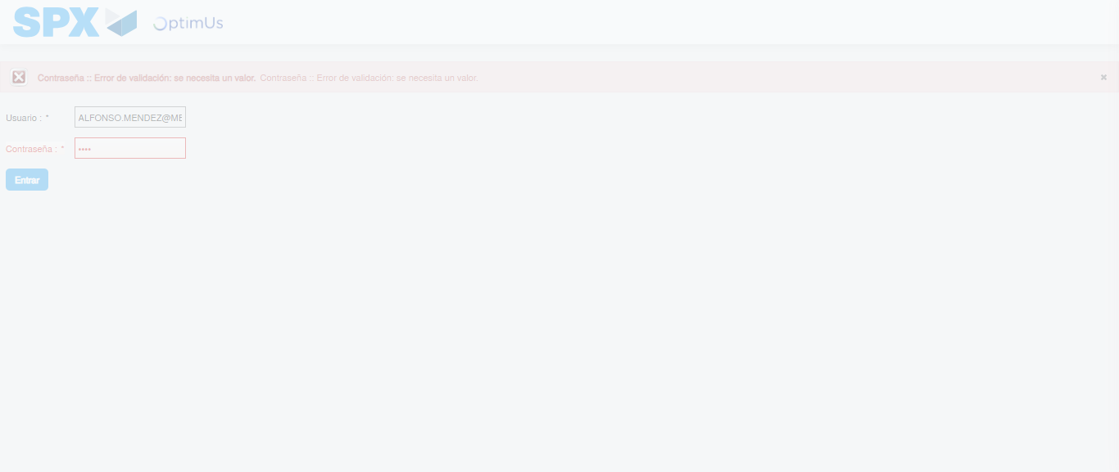Image file-name: QC_Testing-tc002_SPX_Dev5_Crear_Requisicion_Spot_Tipo_Cobro_Project-1783382404734

Step 2 - Select to UEN and Access to Spot Buy Requisitions : UEN Correctly selected and Correct access
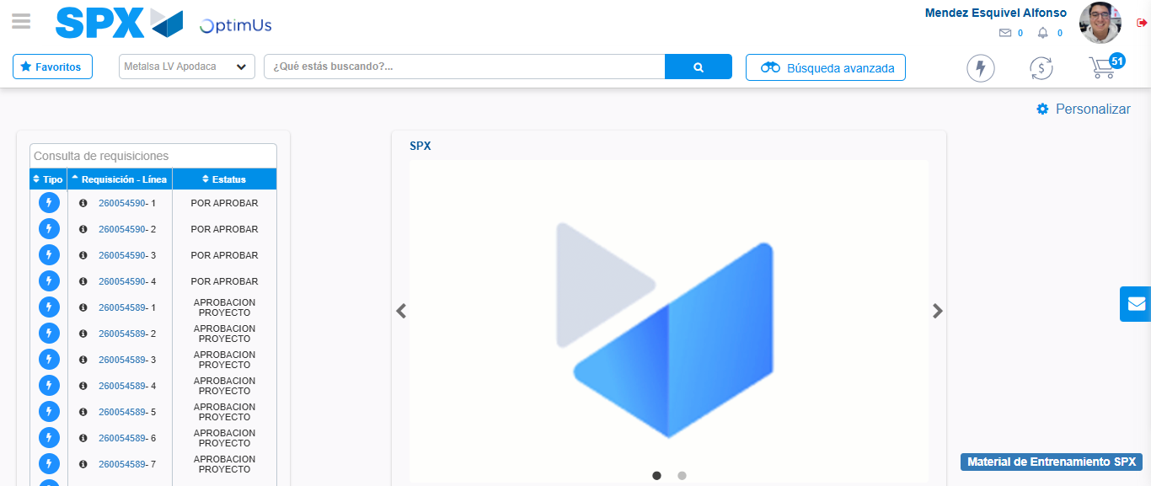Image file-name: QC_Testing-tc002_SPX_Dev5_Crear_Requisicion_Spot_Tipo_Cobro_Project-1783382441214

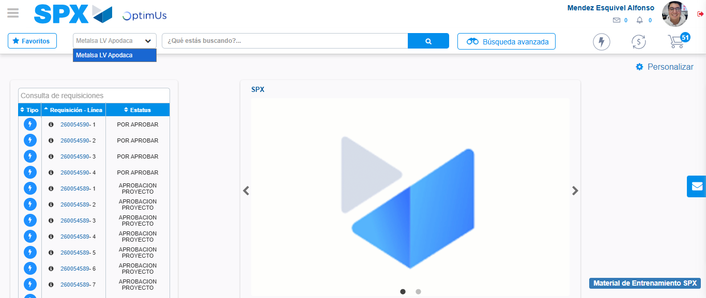Image file-name: QC_Testing-tc002_SPX_Dev5_Crear_Requisicion_Spot_Tipo_Cobro_Project-1783382443727

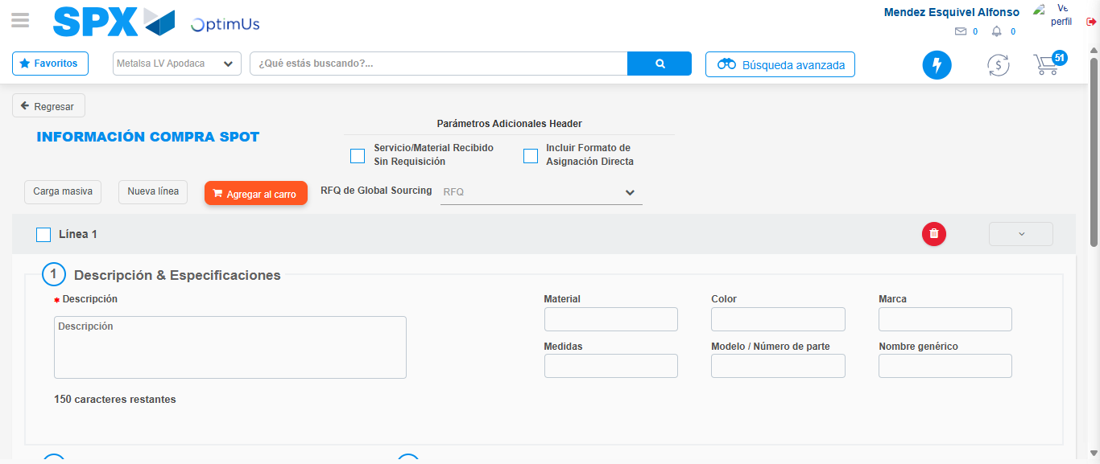Image file-name: QC_Testing-tc002_SPX_Dev5_Crear_Requisicion_Spot_Tipo_Cobro_Project-1783382452071

Step 3 - Data Capture Spot Buy Requisition: Data captured correctly
Image file-name: QC_Testing-tc002_SPX_Dev5_Crear_Requisicion_Spot_Tipo_Cobro_Project-1783382452308

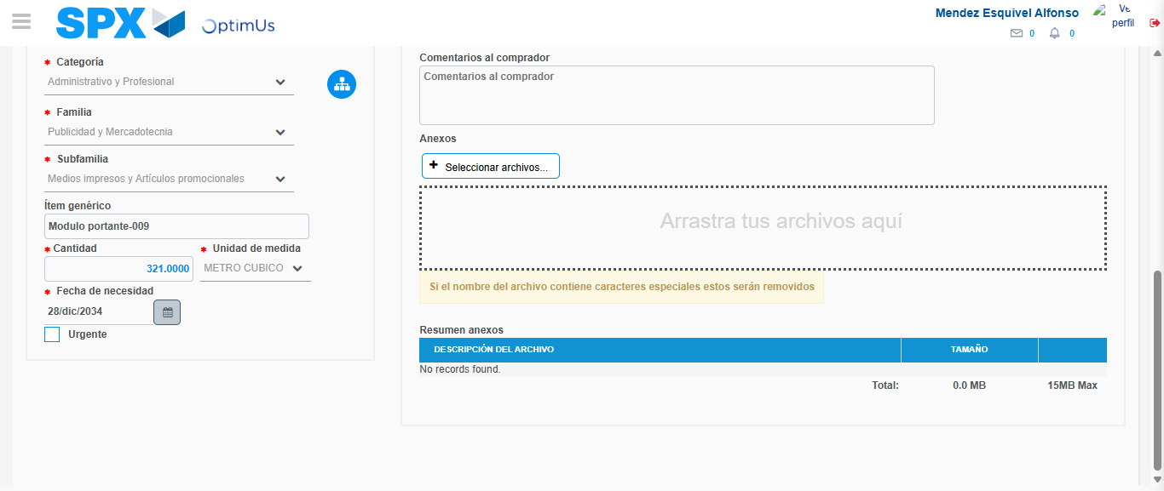Image file-name: QC_Testing-tc002_SPX_Dev5_Crear_Requisicion_Spot_Tipo_Cobro_Project-1783382463310

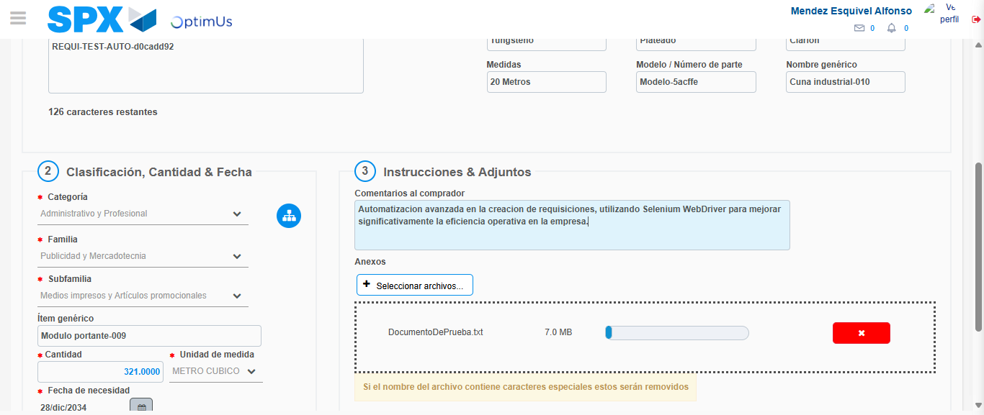Image file-name: QC_Testing-tc002_SPX_Dev5_Crear_Requisicion_Spot_Tipo_Cobro_Project-1783382464065

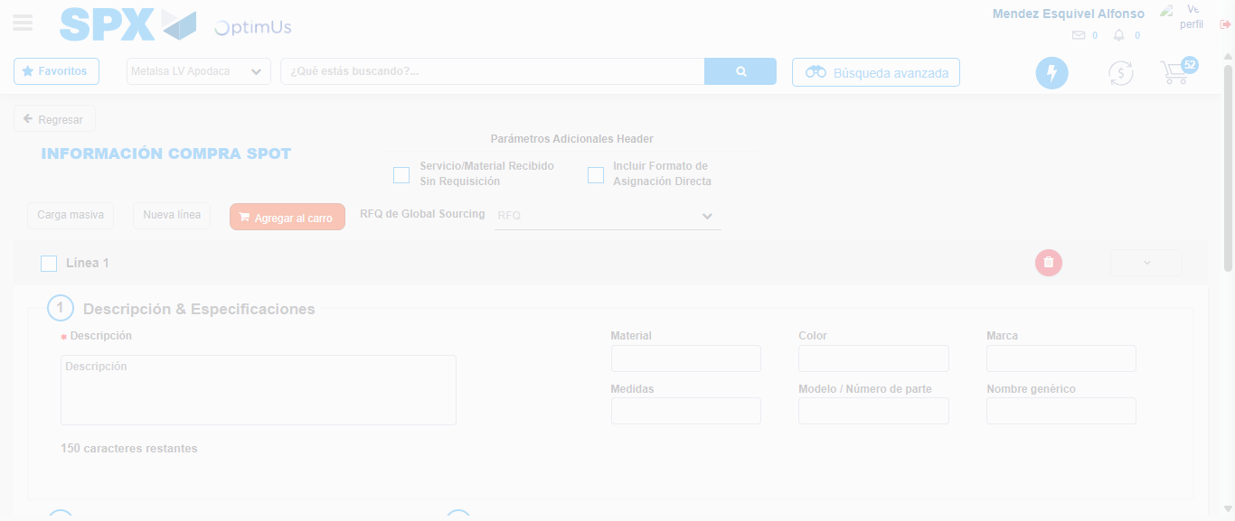Image file-name: QC_Testing-tc002_SPX_Dev5_Crear_Requisicion_Spot_Tipo_Cobro_Project-1783382471375

Step 7 - Return to Main Page SPX : Return to Main Page SPX
Image file-name: QC_Testing-tc002_SPX_Dev5_Crear_Requisicion_Spot_Tipo_Cobro_Project-1783382441214

Image file-name: QC_Testing-tc002_SPX_Dev5_Crear_Requisicion_Spot_Tipo_Cobro_Project-1783382443727

Image file-name: QC_Testing-tc002_SPX_Dev5_Crear_Requisicion_Spot_Tipo_Cobro_Project-1783382452071

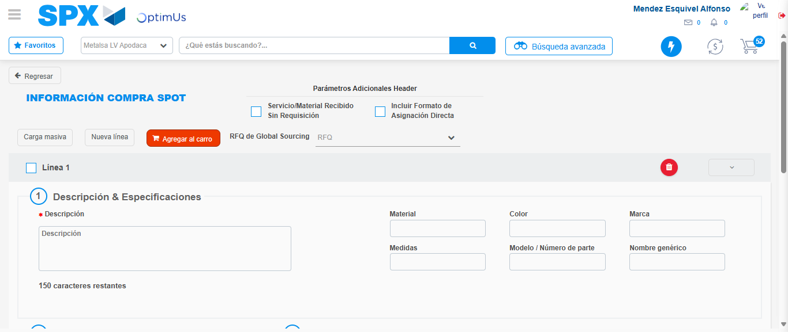Image file-name: QC_Testing-tc002_SPX_Dev5_Crear_Requisicion_Spot_Tipo_Cobro_Project-1783382473590

Image file-name: QC_Testing-tc002_SPX_Dev5_Crear_Requisicion_Spot_Tipo_Cobro_Project-1783382473794

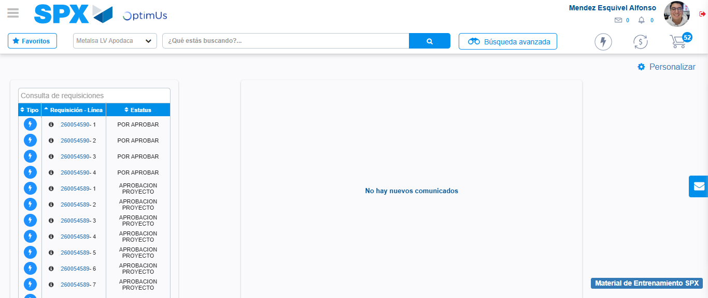Image file-name: QC_Testing-tc002_SPX_Dev5_Crear_Requisicion_Spot_Tipo_Cobro_Project-1783382494878

Step 8 - Log Out : Log Out SPX
Image file-name: QC_Testing-tc002_SPX_Dev5_Crear_Requisicion_Spot_Tipo_Cobro_Project-1783382495068

